|  |  |
| --- | --- |
| Stella Nova Logo | LOGO4 |
| Best Buy Canada Mobile | |
| |  | | --- | | **Layaway Deposit Feature Document** |   **Document Version: 1.3**  **Design Date: October 14, 2013** | |
| **Prepared By: Amy Lackas** | |
|  | |

**Table of Contents**

*1.**Feature Overview* 3

1.1 Feature Description 3

1.2 Assumptions 3

1.3 Parameters and System Settings 3

1.4 Interfaces 3

*2.**USE CASE: Initiate Layaway Deposit* 3

2.1 Feature Flow 3

2.2 Precondition 3

2.3 Main Flow 3

2.4 Alternate Flows 3

2.5 Post Condition 4

2.6 Special Requirements 4

*3.**USE CASE: Add Layaway Deposit Item* 5

3.1 Feature Flow 5

3.2 Precondition 5

3.3 Main Flow 5

3.4 Alternate Flows 5

3.5 Post Condition 6

3.6 Special Requirements 6

*4.**USE CASE: Complete Layaway Deposit Transaction* 7

4.1 Feature Flow 7

4.2 Precondition 8

4.3 Main Flow 8

4.4 Alternate Flows 9

4.5 Post Condition 9

4.6 Special Requirements 9

*5.**Supplemental Specifications* 10

5.1 Deal Service 10

5.2 Electronic Journal 10

5.3 Modify Item Feature 10

5.4 Modify Transaction Feature 10

5.5 POSLog 11

5.6 Printed Receipts 11

5.7 Sale Feature 11

5.8 Suspend Feature 11

5.9 Tender Feature 11

5.10 Total Processing Feature 11

5.11 Training Mode Feature 11

*6.**Screen Layouts* 12

6.1 Layaway Deposit Item Entry 12

6.2 Enter Layaway Deposit Amount 14

6.3 Tender Options 16

*7.**Layaway Deposit Issue – Database settings* 17

*8.**Business Sign Off* 18

*9.**Revision History* 18

10. Appendix A: Source Documentation 18

10.1 Functional Requirements 18

*11.**Appendix* B*: Glossary* 18

*12.**Appendix B: Receipt Example* 19

12.1 Layaway Deposit 19

*13.**Appendix C: POSLog Example* 20

13.1 Layaway Deposit 20

*14.**Appendix D: EJ Example* 21

14.1 Layaway Deposit 21

# *Feature Overview*

## Feature Description

The Layaway Deposit feature document describes the functionality of creating a layaway deposit transactions by adding or editing items. Additional functionality is available within the Sale feature to modify items or the transaction such as capturing a serial number, and verifying the age of the customer. The Layaway Deposit feature document ends when the operator selects to pay for (tender) the transaction.

## Assumptions

1. All quantity required items will have quantity of 1.
2. All text displayed by the system is configurable by brand to support multi-language.  Text is defined from an external source or defined within the system.

## Parameters and System Settings

|  |  |  |
| --- | --- | --- |
| **Parameter Mnemonic** | **Description** | **Valid Values** |
| Layaway Item Attribute | The item attribute that determines if the item qualifies to be added to the layaway deposit transaction. | * On * Off |

## Interfaces

|  |  |
| --- | --- |
| **Interface** | **Description** |
| None |  |

# *USE CASE: Initiate Layaway Deposit*

## Feature Flow

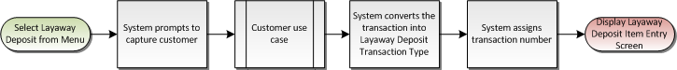

## Precondition

* Sale Transaction has not started.
* Layaway Deposit menu option is selected.

## Main Flow

1. The system executes the Customer use case.
2. If the system returns from the Customer use case with a not completed status, the use case ends and the system returns to the Sale use case without starting the pre-order deposit transaction.
3. If the system returns from the Customer use case with a completed status, the system changes the transaction type to Layaway Deposit.
4. The system assigns a transaction number to the transaction.
5. The use case ends and the system displays the item entry for layaway deposit transaction.

## Alternate Flows

### Alternate Flow 1

None

## Post Condition

* Layaway Deposit transaction is started.

## Special Requirements

1. Once a Layaway Deposit Transaction has started, the following transaction modifications are available, all other transaction modifications are not available (**Note**: Those menu options that are not available once a transaction has started will also not be available during Layaway Deposit Transaction, such as Reprint Receipt.):
   1. Available Modify Transaction Menu Options
      1. Sales Person Capture
      2. Transaction Void
      3. Suspend
      4. Transaction Transfer
      5. Tax Override
      6. Tax Exempt
      7. Kits on the Fly
      8. Loyalty Lookup
   2. Not Available Modify Transaction Menu Options
      1. Employee
      2. Transaction Gift Receipt
      3. GRID/WFMS – Service Order Scheduling
      4. Inventory Lookup

### Special Offline Requirements

TBD

### Data Input/Output

|  |  |  |
| --- | --- | --- |
| **Data Element** | **Description** | **Destination** |
| Layaway Deposit Transaction Type ID | The transaction type ID for layaway deposit (97). | * POSLog |
| Layaway Deposit Transaction Type | The text that determines that the transaction is a layaway deposit transaction. The text to print in the EJ is ‘***LAYAWAY DEPOSIT***’ | * E-Journal |

# *USE CASE: Add Layaway Deposit Item*

## Feature Flow

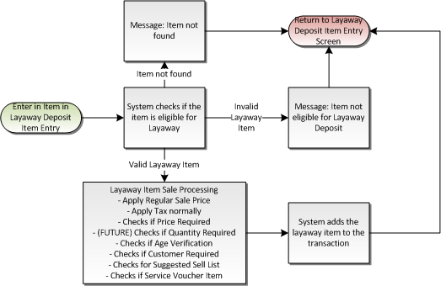

## Precondition

* An item is added to a layaway deposit transaction.

## Main Flow

1. The system validates the entered item.
2. If the item is not found, the system displays a message that item not found; the operator acknowledges the message and the use case ends and the system returns to the Layaway Deposit Item Entry.
3. If the item is not a valid layaway item, the system displays a message that the item is not eligible for layaway; the operator acknowledges the message and the use case ends and the system returns to the Pre-Order Item Entry.
4. If the item is a valid layaway item, the Layaway Item Sale Processing Alternate Flow is executed.
5. The system adds the item to the transaction.
6. The system returns to the Layaway Deposit Item Entry screen.

## Alternate Flows

### Layaway Item Sale Processing

1. If the item requires a minimum age for purchase, the Age Verification use case is executed.
2. If the item requires customer capture, the Customer use case is executed.
3. If the item requires price to be captured, the Price Required use case is executed.
4. If the item does not require price to be capture, the system applies the regular price to the item.
5. The system calls the SNT Tax Service for the item with the item price.
6. The system executes the Related Item – Suggested Sell use case.
7. The system returns to the Main Flow where the system adds the item to the transaction.

## Post Condition

* A Layaway item is sold.

## Special Requirements

1. The suggested sell list is determined normally for the item and displayed the same way as a regular sale item.
2. If at least one item in the Layaway Deposit Transaction has the Print Service Voucher attribute, the system prints the service voucher for the transaction as it does for a regular sale transaction.
3. Valid Layaway requirements:
   1. Layaway Deposit item attribute enabled on the item.
4. The system does not look at the ability to sell item on device item attribute when determining if the item can be sold as Layaway:
5. If a Layaway item is setup for one of the following item attributes or database setup, the system will **not** execute the process during the selling of an item in a Layaway Deposit Transaction:
   1. Schedulable Service Item Attribute
   2. Activation (such as Phone Cards, Third Party Gift Cards, Gift Cards)
   3. Serial Number
   4. Relationships of the type Mandatory, Mandatory-Optional – includes Subscription and Tier 2/3 (Linked SKU) relationships
   5. Custom Prompts
   6. Capture Credit Card
   7. Manager Approval on item
   8. Signature Capture with Terms on item
6. A open-box item is not eligible for Layaway. If an open box tag is entered, the system does not execute the Open Box Item use case. The system displays the item not found message.
7. Once an item is added to the transaction, the following Item Modifications are available, all other Item Modifications are not available:
   1. Available Item Modify Menu Options
      1. Sales Person Capture
      2. Item Void
      3. Tax Exempt
      4. Tax Override
      5. Price Override
      6. Manual Item Discount
   2. Not Available Item Modify Menu Options
      1. Raincheck
      2. Item Gift Receipt

### Special Offline Requirements

TBD

### Data Input/Output

|  |  |  |
| --- | --- | --- |
| **Data Element** | **Description** | **Destination** |
| Item Number | SKU number associated with a sales item. If the item is sold via UPC or Open Box Item processing, this is the SKU number associated with these values. | * E-Journal * POSLog * Receipt |
| Item Description | Description of item being sold. | * E-Journal * POSLog * Receipt |
| Quantity | Number of item sold for a given line number. | * E-Journal * POSLog * Receipt |
| Item Price | The price of a sales item. | * E-Journal * POSLog * Receipt |

# *USE CASE: Complete Layaway Deposit Transaction*

## Feature Flow

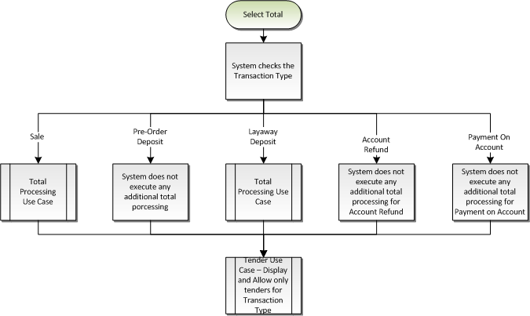

Figure : Select Total Overall Process

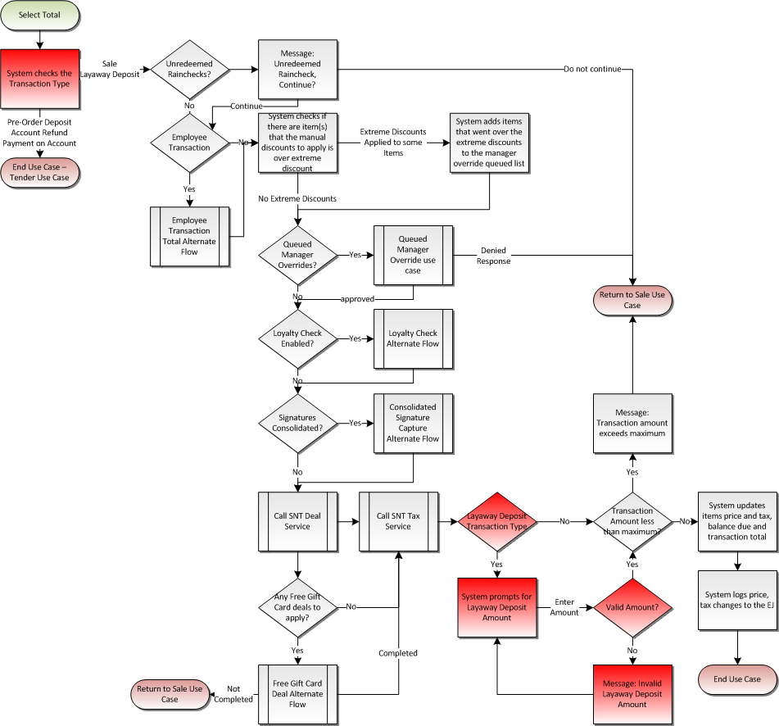

Figure : Total Processing

## Precondition

* An item is added to a layaway deposit transaction.
* Total is selected on the Layaway Deposit Item Entry screen

## Main Flow

See Total Processing Feature Document

## Alternate Flows

### Alternate Flow 1

None

## Post Condition

* Layaway Deposit Transaction is completed.

## Special Requirements

1. During the Deal Service, the system does not apply any free gift card value packages to items.
2. After the Deal and Tax service has been called and the amounts have been applied to the appropriate items, the system prompts for the user to enter the amount to put down for as the layaway deposit.
   1. A valid amount is greater than zero but less than or equal to the transaction total (after deal and tax service has been executed and applied to the transaction).
   2. If an invalid amount is entered, the system displays a message and returns to the enter layaway deposit amount.
3. The system allows only certain tenders to be used during a layaway deposit transaction. **Note**: The current setup is to not allow Loyalty Certificates and Finance Plan Tenders to be added to pre-order deposit transaction.
4. Receipt header, pre-footer and footer messages are setup for the Layaway Deposit Transaction type
   1. If there is Layaway Deposit transaction type receipt header, pre-footer or footer messages defined, the system prints the standard sale header, pre-footer or footer message.
5. The item receipt messaging is not printed on Layaway Deposit Transaction Receipt.
6. Layaway Deposit Transaction is eligible to be reprinted during a Reprint Receipt option.
7. Layaway Deposit Transaction is not eligible to printed during a Reprint Gift Receipt option.
8. The ‘Total Quantity Sold’ line on the receipt is not printed for a Layaway Deposit Transaction.

### Special Offline Requirements

TBD

### Data Input/Output

|  |  |  |
| --- | --- | --- |
| **Data Element** | **Description** | **Destination** |
| Final Layaway Deposit Amount | After the total and tender lines, the system prints the final deposit amount in the EJ after the transaction has been completely tendered. The text is the following “FINAL LAYAWAY DEPOSIT”. | * E-Journal |
| Transaction Type ID | The transaction type ID for Layaway Deposit is written to the POSLog. | * POSLog |
| Layaway Line Item Data | Each item sold in a Layaway Deposit Transaction is written as a Layaway Line Item. | * E-Journal * POSLog |
| Payment on Account Line Item | A Payment on Account Line Item is written with the entered total Layaway Deposit amount. | * POSLog |
| Transaction Type Text | The transaction type is printed on the receipt below the transaction key information. | * Receipt |
| Transaction Receipt Messaging | The header, pre-footer, footer messaging that setup for the Pre-Order Deposit Transaction Type. | * Receipt |

# *Supplemental Specifications*

## Deal Service

The Deal service is executed during a Layaway Deposit transaction, with the exception that the Free Gift Card Value Packages will not be applied to the Layaway Deposit transaction.

## Electronic Journal

Electronic journal mockups for this feature are documented in the Electronic Journal document.

## Modify Item Feature

Once a Layaway Deposit transaction has been started only the following is the availability of item modification:

1. Available Item Modify Menu Options
2. Sales Person Capture
3. Item Void
4. Tax Exempt
5. Tax Override
6. Price Override
7. Manual Item Discount
8. Not Available Item Modify Menu Options
9. Raincheck
10. Item Gift Receipt

## Modify Transaction Feature

The Modify Transaction use case is updated to add the option to start a Layaway Deposit transaction type. The option is only available if a transaction has not already been executed.

Once a Layaway Deposit transaction has been started only the following is the availability of transaction modification:

1. Available Modify Transaction Menu Options
2. Sales Person Capture
3. Transaction Void
4. Suspend
5. Transaction Transfer
6. Tax Override
7. Tax Exempt
8. Kits on the Fly
9. Loyalty Lookup
10. Not Available Modify Transaction Menu Options
11. Employee
12. Transaction Gift Receipt
13. GRID/WFMS – Service Order Scheduling
14. Inventory Lookup

## POSLog

POSLog mockups for this feature are documented in the POSLog document. Layaway Deposit is its own transaction type. The system filters out tax nodes from the POSLog and removes any links to tax nodes, and zeros out the transaction tax. A Payment on Account node is written to the POSlog with the layaway deposit amount to the appropriate account number.

## Printed Receipts

Printed receipt mockups, where applicable, are documented in the Receipt Generation document. The Layaway Deposit is its own transaction type with its own receipt messaging. The items and transaction total lines remain on the receipt as a regular sale, but the system displays the LAYAWAY DEPOSIT total as a separate line on the receipt.

## Sale Feature

A modified version of the sale process is executed on the items.

1. The system does not look at the ability to sell item on device item attribute when determining if the item can be sold as Layaway:
2. If a Layaway item is setup for one of the following item attributes or database setup, the system will **not** execute the process during the selling of an item in a Layaway Deposit Transaction:
   1. Schedulable Service Item Attribute
   2. Activation (such as Phone Cards, Third Party Gift Cards, Gift Cards)
   3. Serial Number
   4. Relationships of the type Mandatory, Mandatory-Optional – includes Subscription and Tier 2/3 (Linked SKU) relationships
   5. Custom Prompts
   6. Capture Credit Card
   7. Manager Approval on item
   8. Signature Capture with Terms on item

## Suspend Feature

The Suspend Use Case is updated to reflect that the data captured prior to suspending a transaction is available when the transaction is resumed. A layaway deposit transaction is eligible to be suspended.

## Tender Feature

The Tender use case is updated to display only tenders available for the transaction type.

## Total Processing Feature

The Total Processing use case is updated to add the layaway check and capture the final layaway deposit amount to the flow.

## Training Mode Feature

The Training Mode use case is updated to add the Layaway Deposit feature to Training Mode and no updates required to feature.

# *Screen Layouts*

## Layaway Deposit Item Entry

This screen allows the operator to add items to a Layaway Deposit transaction or select an option from the menu. The system displays the transaction type text on the top of the screen. Once an item is added to the transaction, the system displays the item description, SKU and pre-order deposit price. The transaction summary area shows the transaction’s subtotal, tax total and transaction total.

### Mockup

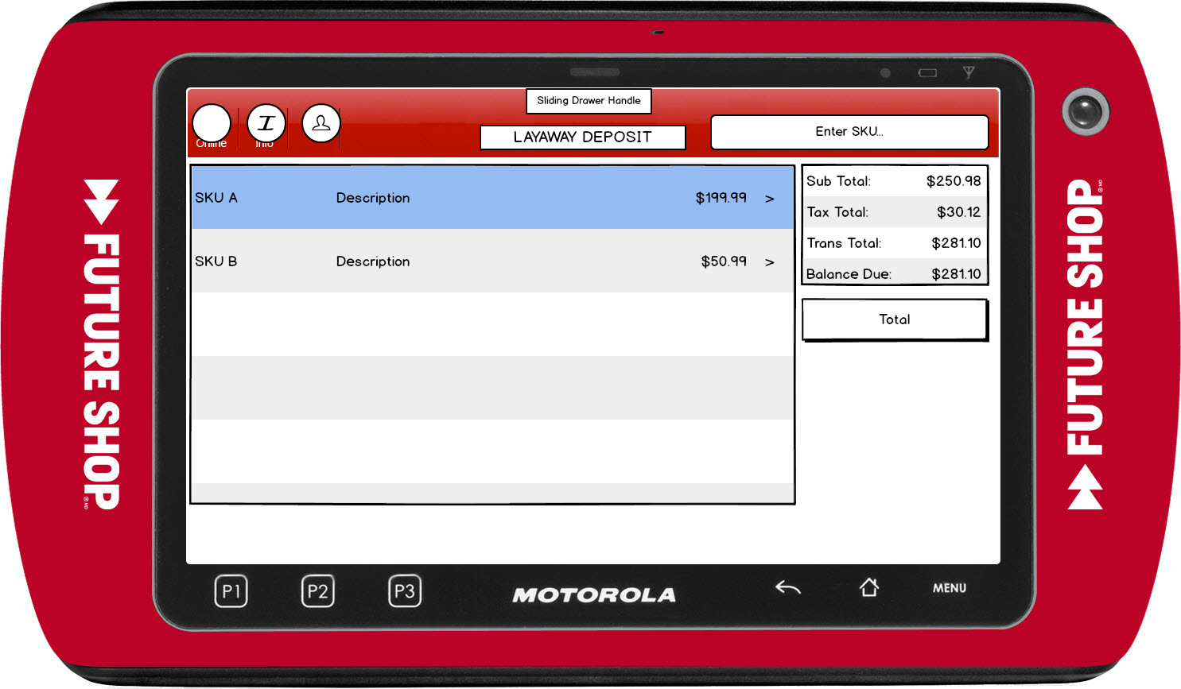

Figure : Layaway Deposit Item Entry

### Instruction Text

|  |
| --- |
| **Instructions** |
| LAYAWAY DEPOSIT |

### Navigation/Menu Key

|  |  |  |  |
| --- | --- | --- | --- |
| **Label Text** | **State** | **Next Screen** | **Notes** |
| Information | Enabled | Information | None |
| Item Entry | See Note | Item Entry | Scanner and keyboard are valid entry methods |
| Sliding Drawer Handle | Enabled | Tran Modify use case | Only the following Transaction Modifications are available for Pre-Order Deposit Transaction:   * Sales Person Capture * Transaction Void * Suspend * Transaction Transfer * Tax Override * Tax Exempt * Kits on the Fly * Loyalty Lookup |
| Item Modify | Enabled | Item Modify use case | Only the following Item Modifications are available for Pre-Order Deposit Transaction:   * Sales Person Capture * Item Void * Tax Exempt * Tax Override * Price Override * Manual Item Discount |
| Total | See Notes | Total use case | Enabled once a transaction is in progress |

### Data/Input Field

***Note****: The Data/Input fields are the same as the Sale Item Entry.*

|  |  |  |  |  |  |  |
| --- | --- | --- | --- | --- | --- | --- |
| **Label/Placeholder Text** | **Editable** | **Req’d?** | **Data Type** | **Min**  **Length** | **Max**  **Length** | **Notes** |
| SKU | No | N/A | Numeric | 1 | 8 | Display Only |
| Price | No | N/A | Currency | 4 | 9 | Display Only |
| Description | No | N/A | Text | 1 | 32 | Display Only |
| Subtotal: | No | N/A | Currency | 4 | 9 | Display Only |
| Tax Total: | No | N/A | Currency | 4 | 9 | Display Only |
| Total: | No | N/A | Currency | 4 | 9 | Display Only |
| Balance Due | No | N/A | Currency | 4 | 9 | Display Only |

### Reason Code

|  |  |  |
| --- | --- | --- |
| **Reason Code** | **Valid Values** | **Default Value** |
| None |  |  |

### Item Not Found

|  |  |
| --- | --- |
| **Description** | This message is displayed when the item that is entered is not found in the database. Acknowledging the message returns the operator to the Layaway Deposit Item Entry screen. |
| **Message** | Item not found |
| **Key prompt** | OK |
| **Notes** | Configurable message |

### Item Not Eligible for Layaway Deposit

|  |  |
| --- | --- |
| **Description** | This message is displayed when the item that is entered in a Layaway Deposit transaction is not a valid Layaway Item. Acknowledging the message returns the operator to the Layaway Deposit Item Entry screen. |
| **Message** | The item is not eligible for Layaway Deposit |
| **Key prompt** | OK |
| **Notes** | Configurable message |

## Enter Layaway Deposit Amount

During the total process, if the transaction type is Layaway Deposit, the system prompts to capture the amount the customer wishes to put down on the layaway transaction. The system pre-populates with the existing transaction total (after Deal and Tax service has been executed and applied to the transaction). The layaway deposit must be greater than zero but less than or equal to the transaction total.

### Mockup

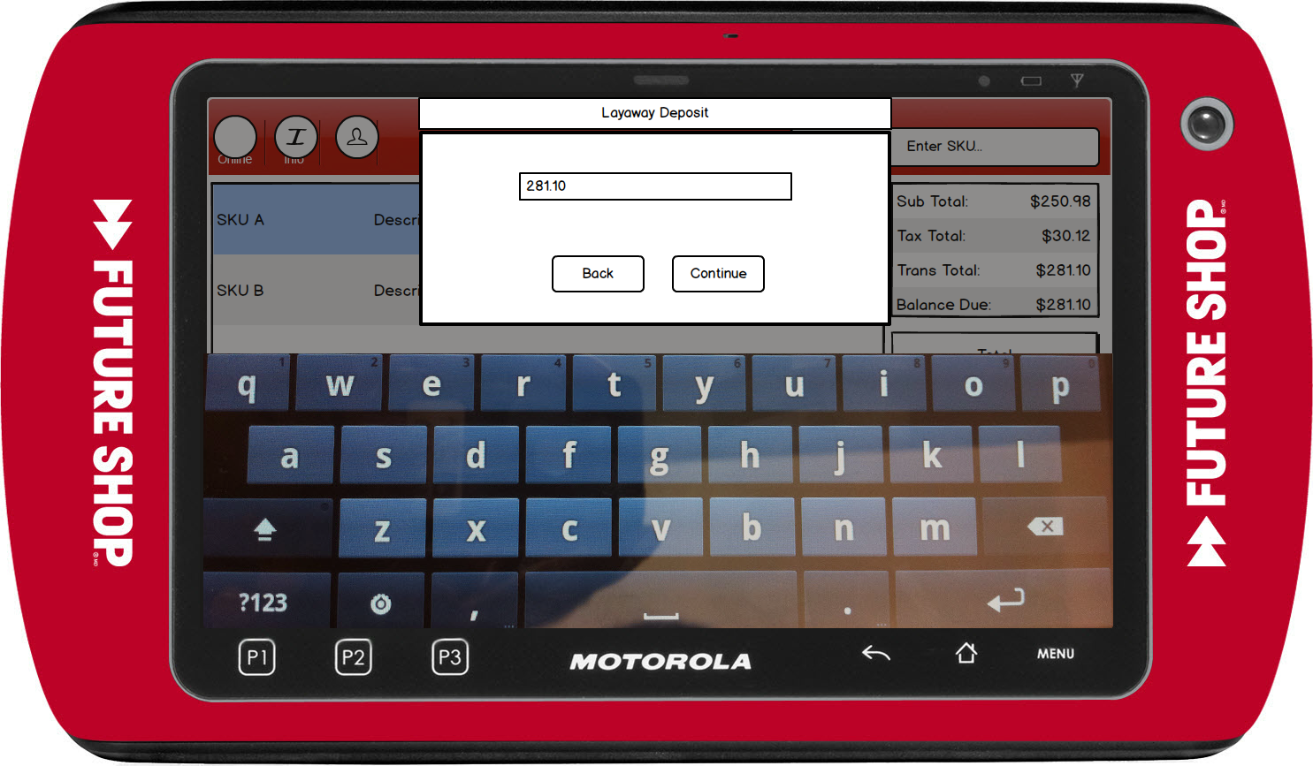

Figure : Layaway Deposit Tender

### Instruction Text

|  |
| --- |
| **Instructions** |
|  |

### Navigation/Menu Key

|  |  |  |  |
| --- | --- | --- | --- |
| **Label Text** | **State** | **Next Screen** | **Notes** |
| Back | Enabled | Layaway Deposit Item Entry |  |
| Continue | See Notes | * Valid Amount: Tender with Balance Due the amount entered * Invalid Amount: Invalid Daga | Only enabled when data is entered in the field |

### Data/Input Field

***Note****: The Data/Input fields are the same as the Sale Item Entry.*

|  |  |  |  |  |  |  |
| --- | --- | --- | --- | --- | --- | --- |
| **Label/Placeholder Text** | **Editable** | **Req’d?** | **Data Type** | **Min**  **Length** | **Max**  **Length** | **Notes** |
| Enter item price and select Continue | Yes | Yes | Currency | 3 | 12 | None |

### Reason Code

|  |  |  |
| --- | --- | --- |
| **Reason Code** | **Valid Values** | **Default Value** |
| None |  |  |

### Invalid Data

|  |  |
| --- | --- |
| **Description** | This message is displayed when the entered layaway deposit amount is not valid. |
| **Message** | Invalid data |
| **Key prompt** | OK |
| **Notes** | Configurable message |

## Tender Options

This screen allows the operator to select the tender to complete the transaction.

Upon initial entry to this screen and the transaction type is Layaway Deposit, the Balance Due shows the amount the customer entered in the Enter Layaway Deposit Amount screen.

The available tenders are based upon the transaction type and the tenders available for the device type. The process to capture the tenders are the same as defined in their respective feature documents. For Layaway Deposit transaction, Loyalty Certificates are not allowed as a tender type.

### Mockup

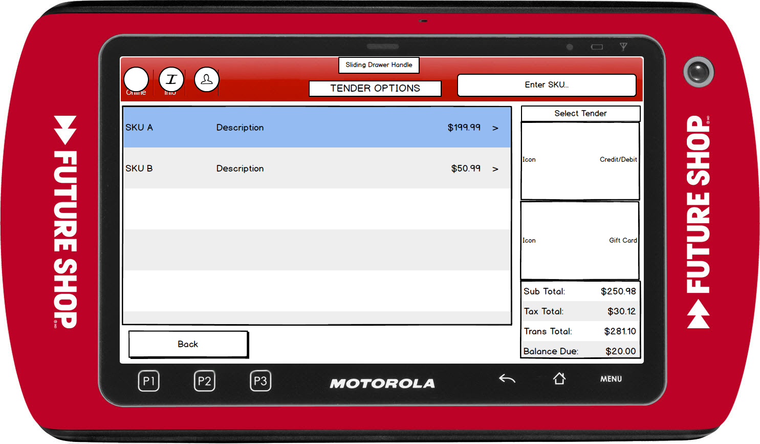

Figure : Tender – Layaway Deposit

### Instruction Text

|  |
| --- |
| **Instructions** |
|  |

### Navigation/Menu Key

***Note****: The Tender options do not have any additional processing for the transaction type, the process is the same as already documented. An additional parameter(s) is added to enable tenders based upon the transaction type – this is defined for each transaction type.*

|  |  |  |  |
| --- | --- | --- | --- |
| **Label Text** | **State** | **Next Screen** | **Notes** |
| Back | Enabled | Layaway Deposit Item Entry | None |
| Credit/Debit | See Notes | Credit-Debit-EMV use case | The tender option is displayed based upon the Available Tenders by Device parameter. |
| Gift Card | See Notes | Gift Card use case | The tender option is displayed based upon the Available Tenders by Device parameter and Available Tenders for Transaction Type. |
| Store Credit | See Notes | Store Credit Card use case | The tender option is displayed based upon the Available Tenders by Device parameter and Available Tenders for Transaction Type. |
| Loyalty Certificate | See Notes | Loyalty Certificate Tender use case | The tender option is displayed based upon the Available Tenders by Device parameter and Available Tenders for Transaction Type.  Loyalty Certificate is not displayed if a different tender has been used in the transaction. |

### Data/Input Field

***Note****: The Data/Input fields are the same as the Tender Option screen, with the exception of the Balance Due. The initial Balance Due is the entered amount to put down for layaway deposit.*

|  |  |  |  |  |  |  |
| --- | --- | --- | --- | --- | --- | --- |
| **Label/Placeholder Text** | **Editable** | **Req’d?** | **Data Type** | **Min**  **Length** | **Max**  **Length** | **Notes** |
| Enter amount and select tender type. | Yes | No | Currency | 1 | 8 | If an entry is not made, the system uses the balance due as the tender amount for the tender that is selected. |
| Balance Due | No | N/A | Currency | 1 | 9 | Upon initial entry to the screen, the value is the entered layaway deposit amount. |

### Reason Code

|  |  |  |
| --- | --- | --- |
| **Reason Code** | **Valid Values** | **Default Value** |
| None |  |  |

# *Layaway Deposit Issue – Database settings*

* Get the LayawayEligible Item attribute from Common.Attribute table

|  |  |  |  |  |
| --- | --- | --- | --- | --- |
|  | ID | Name | Data Type | Custom |
|  | This column contains list of values (all are Dynamic values) | LayawayEligible | System.Boolean | *0* |

* Get the ItemLocationId from Item.ItemLocationAttributeValue table for above Attribute ID.

|  |  |  |  |  |
| --- | --- | --- | --- | --- |
|  | ID | AttributeId | ItemLocationID | Value |
| 1 | This column contains list of values (all are Dynamic values) | This column contains list of Attribute ID’s | Contains list of ItemLocationID’s | *True or False*  *True: Eligible for Layaway*  *False: Not Eligible for Layaway* |

* Get the ItemId from Item.ItemLocation table for above ItemLocationID
* Get the ItemCode from Item.Item table for above ItemId

# *Business Sign Off*

|  |  |  |
| --- | --- | --- |
| **Name** | **Organization** | **Date** |
|  |  |  |

# *Revision History*

|  |  |  |  |
| --- | --- | --- | --- |
| **Reviser** | **Revision** | **Date** | **Version** |
| Amy Lackas | Initial document created. | 10/14/2013 | 1.0 |
| Amy Byers | Removed not evaluating related item outside item attribute for layaway transactions. | 4/8/2014 | 1.2 |
| Amy Byers | Added requirement matrix | 10/6/2014 | 1.3 |

# Appendix : Source Documentation

* Requirement Specification - XPOS.xlsx

## Functional Requirements

| **ID** | **Sub Category** | **Description** | **Section(s)** |
| --- | --- | --- | --- |
| 2.40 | Layaway Deposit | Layaway Deposit functionality will be added to XPOS allowing a user to issue Layaway Deposits. | * 1 Feature Overview * 2 USE CASE: Initiate Layaway Deposit * 3 USE CASE: Add Layaway Deposit Item * 4 USE CASE: Complete Layaway Deposit Transaction * 5 Supplemental Specifications |
| 2.40.5 | Layaway Deposit | The Layaway Deposit invoice will indicate the price of the item as well as the amount that was applied to the Layaway Deposit. | * 12Appendix B: Receipt Example |

# *Appendix : Glossary*

|  |  |
| --- | --- |
| **Term** | **Definition** |
|  |  |

# *Appendix B: Receipt Example*

## Layaway Deposit

|  |  |
| --- | --- |
| Welcome to Best Buy #998  Corp POS Lab, BC  (999) 999-9999  POS LAB TESTING    Val # 1234-2432-2344-2542  0980 001 0362 02/19/13 15:31 W735  Phone#: 604-981-4300  **LAYAWAY DEPOSIT**  10001000 Item Desc 199.99  Item long description  10001001 CA-3552 49.97  CYBER CA-3552  --------  SUBTOTAL 249.96  HST BC 30.00    TOTAL 279.96  LAYAWAY DEPOSIT 50.00  ACCT#: 0980 001 0362 02/19/13  CDN CASH 50.00  <<Configurable Receipt Message for Transaction Type>>  … |  |
| Figure 6: Layaway Deposit |  |

# *Appendix C: POSLog Example*

## Layaway Deposit

**LineItem – Layaway**

<LineItem EntryMethod=”Keyed’>

<LineNumber>1</LineNumber>

<Layaway>

<ItemTypeAttributes>

<ItemType>PSPEligible</ItemType>

</ItemTypeAttributes>

<ItemID>10001000</ItemID>

<ItemNotOnFileFlag>false</ItemNotOnFileFlag>

<Description>SPEAKERS</Description

<RegularSalesUnitPrice Currency=”CAD” UnitOfMeasureCode=”EA”>199.99</RegularSalesUnitPrice>

<ActualSalesUnitPrice Currency=”CAD” UnitOfMeasureCode=”EA”>199.99</ActualSalesUnitPrice>

<ItemCost Currency=”CAD”>199.99</ItemCost>

<ExtendedAmount Currency=”CAD”>199.99</ExtendedAmount>

<DiscountAmount Currency=”CAD”>0</DiscountAmount>

<ExtendedDiscountAmount Currency=”CAD”>0</ExtendedDiscountAmount>

<MerchandiseReferenceNumber>740020002</MerchandiseReferenceNumber>

<StoreHiearchyID>74</StoreHierarchyID>

<Quantity UnitOfMeasureCode=”EA”>1</Quantity>

<SerialNumber />

<CustomDBData Name=”PriceReasonCode”>C</CustomDBData>

<DBLowestPrice>199.99</DBLowestPrice>

<Department>74</Department>

<ThirdPartyAppIdentifier>0</ThirdPartyAppIdentifier>

<PIMCode>850000000</PIMCode>

<PriceReasonCode>C</PriceReasonCode>

</Layaway>

</LineItem>

**LineItem – Tender**

No difference as too how the tender on a Layway Deposit Transaciton is logged in the POSlog.

**LineItem – Tax**

No Tax LineItem is logged in the POSLog. All reference to the tax is removed from the POSLog.

**LineItem – PaymentOnAccount**

<LineItem>

<LineNumber>5</LineNumber>

<PaymentOnAccount>

<AccountNumber>980^20130219^1^362></TaxAuthority>

<Amount>50.00</Amount>

<ReferenceID/>

</PaymentOnAccount>

</LineItem>

**Total Lines**

The transaction tax total is $0.00. The deposit amount is listed as the Transaction Gross/Tender/Net Amount

<Total TotalType=”TransactionGrossAmount”>50.00</Total>

<Total TotalType=”TransactionTaxAmount”>0.00</Total>

<Total TotalType=”TransactionTenderAmount”>50.00</Total>

<Total TotalType=”TransactionNetAmount”>50.00</Total>

<Total TotalType=”TransactionTaxExemptAmount”>0.00</Total>

**Customer**

No change to how the Customer collected for Layaway Deposit Transaction is logged in the POSLog.

# *Appendix D: EJ Example*

## Layaway Deposit

Transaction No: 362

Operator No: NEWPASS

Terminal No: 1

Salesperson ID:

IBH ENTERPRISE: 1

IBH TRADING AREA: 8

IBH COMPANY: 9

IBH BRAND: 10

IBH BUSINESS UNIT: 18

IBH CHANNEL: 54

MessageBox:CUST_VERIFICATION:Wait for Customer to verify information on Signature Pad.

***LAYAWAY DEPOSIT***

Saving Customer Data.

-----------CUSTOMER ADDRESS-----------

Name: BRANDON LEE

Address: 8800 GLENLYON PARKWAY

Address:

City: BURNABY

State: BC

Zip: V6J1Y1

Country: CAN

Home Phone: 604-981-4300

-----------CUSTOMER ADDRESS-----------

001 10001000 ITEM LONG DESCRIPTION $199.99

TAX HST RATE: 0.1200 AMT: $24.00

TAX AUTHORITY: 2

TAX JURISDICTION: 44315

PIM CODE: 850000000

CUSTOM DB DATA: Price Reason Code: S

001 10001001 CYBER CA-3552 $49.97

TAX HST RATE: 0.1200 AMT: $6.00

TAX AUTHORITY: 2

TAX JURISDICTION: 44315

PIM CODE: 850000000

CUSTOM DB DATA: Price Reason Code: S

>>>Checking package pricing<<<

>>>Back from checking package pricing<<<

CDN Cash $50.00

EN_FINAL LAYAWAY DEPOSI $50.00

ACCT 0980 001 0362 02/19/13

Change Due $0.25

CDN Cash

…